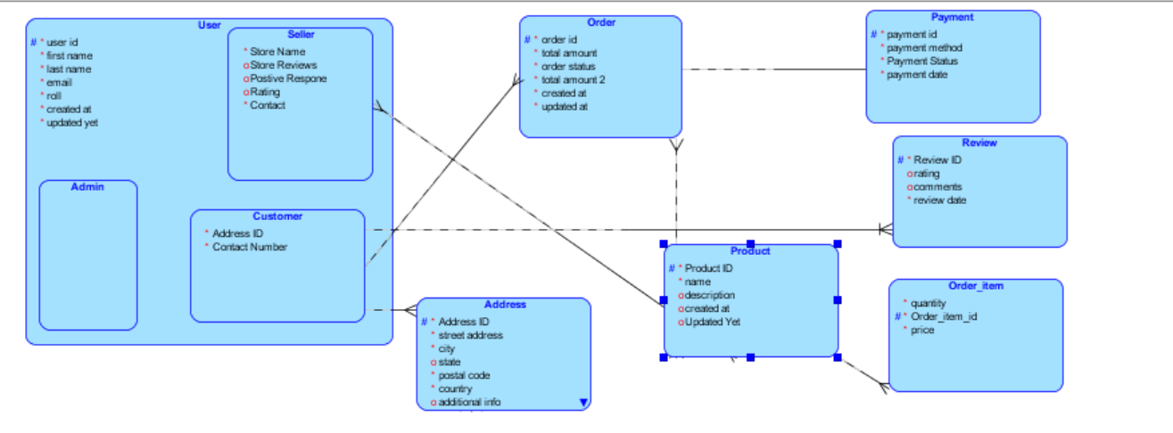

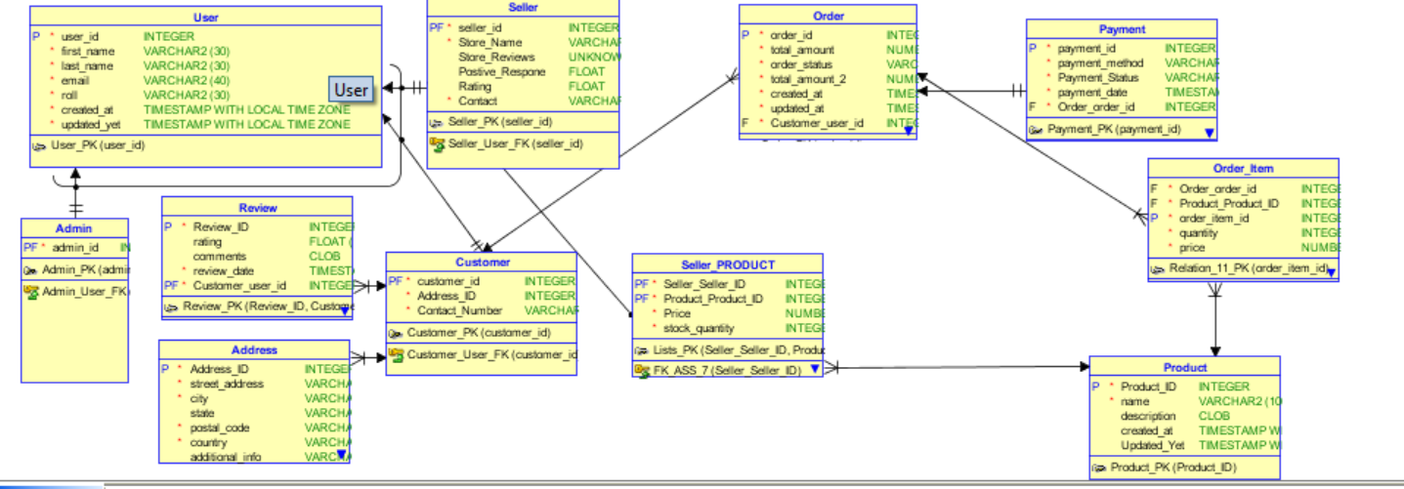

-- Generated by Oracle SQL Developer Data Modeler 4.1.1.888

-- at: 2024-11-19 13:35:53 PKT

-- site: Oracle Database 11g

-- type: Oracle Database 11g

CREATE TABLE Address

(

Address_ID INTEGER NOT NULL ,

street_address VARCHAR2 (255) NOT NULL ,

city VARCHAR2 (255) NOT NULL ,

state VARCHAR2 (255) ,

postal_code VARCHAR2 (20) NOT NULL ,

country VARCHAR2 (100) NOT NULL ,

additional_info VARCHAR2 (255) ,

created_at TIMESTAMP WITH LOCAL TIME ZONE ,

updated_at TIMESTAMP WITH LOCAL TIME ZONE ,

Customer_user_id INTEGER NOT NULL

) ;

ALTER TABLE Address ADD CONSTRAINT Address_PK PRIMARY KEY ( Address_ID ) ;

CREATE TABLE Admin

( admin_id INTEGER NOT NULL

) ;

ALTER TABLE Admin ADD CONSTRAINT Admin_PK PRIMARY KEY ( admin_id ) ;

CREATE TABLE Customer

(

customer_id INTEGER NOT NULL ,

Address_ID INTEGER NOT NULL ,

Contact_Number VARCHAR2 (15) NOT NULL

) ;

ALTER TABLE Customer ADD CONSTRAINT Customer_PK PRIMARY KEY ( customer_id ) ;

CREATE TABLE "Order"

(

order_id INTEGER NOT NULL ,

total_amount NUMBER (10,2) NOT NULL ,

order_status VARCHAR2 (20) NOT NULL ,

total_amount_2 NUMBER (10,2) NOT NULL ,

created_at TIMESTAMP WITH LOCAL TIME ZONE NOT NULL ,

updated_at TIMESTAMP WITH LOCAL TIME ZONE NOT NULL ,

Customer_user_id INTEGER NOT NULL

) ;

ALTER TABLE "Order" ADD CONSTRAINT Order_PK PRIMARY KEY ( order_id ) ;

CREATE TABLE Order_Item

(

Order_order_id INTEGER NOT NULL ,

Product_Product_ID INTEGER NOT NULL ,

order_item_id INTEGER NOT NULL ,

quantity INTEGER NOT NULL ,

price NUMBER (10,2) NOT NULL

) ;

ALTER TABLE Order_Item ADD CONSTRAINT Relation_11_PK PRIMARY KEY ( order_item_id ) ;

CREATE TABLE Payment

(

payment_id INTEGER NOT NULL ,

payment_method VARCHAR2 (30) NOT NULL ,

Payment_Status VARCHAR2 (30) NOT NULL ,

payment_date TIMESTAMP WITH LOCAL TIME ZONE NOT NULL ,

Order_order_id INTEGER NOT NULL

) ;

CREATE UNIQUE INDEX Payment__IDX ON Payment

(

Order_order_id ASC

)

;

ALTER TABLE Payment ADD CONSTRAINT Payment_PK PRIMARY KEY ( payment_id ) ;

CREATE TABLE Product

(

Product_ID INTEGER NOT NULL ,

name VARCHAR2 (100) NOT NULL ,

description CLOB ,

created_at TIMESTAMP WITH LOCAL TIME ZONE ,

Updated_Yet TIMESTAMP WITH LOCAL TIME ZONE

) ;

ALTER TABLE Product ADD CONSTRAINT Product_PK PRIMARY KEY ( Product_ID ) ;

CREATE TABLE Review

(

Review_ID INTEGER NOT NULL ,

rating FLOAT (1) ,

comments CLOB ,

review_date TIMESTAMP WITH LOCAL TIME ZONE NOT NULL ,

Customer_user_id INTEGER NOT NULL

) ;

ALTER TABLE Review ADD CONSTRAINT Review_PK PRIMARY KEY ( Review_ID, Customer_user_id ) ;

CREATE TABLE Seller

(

seller_id INTEGER NOT NULL ,

Store_Name VARCHAR2

-- ERROR: VARCHAR2 size not specified

NOT NULL ,

Store_Reviews UNKNOWN

-- ERROR: Datatype UNKNOWN is not allowed

,

Postive_Respone FLOAT ,

Rating FLOAT ,

Contact VARCHAR2 (15) NOT NULL

) ;

ALTER TABLE Seller ADD CONSTRAINT Seller_PK PRIMARY KEY ( seller_id ) ;

CREATE TABLE Seller_PRODUCT

(

Seller_Seller_ID INTEGER NOT NULL ,

Product_Product_ID INTEGER NOT NULL ,

Price NUMBER (10,2) NOT NULL ,

stock_quantity INTEGER NOT NULL

) ;

ALTER TABLE Seller_PRODUCT ADD CONSTRAINT Lists_PK PRIMARY KEY ( Seller_Seller_ID, Product_Product_ID ) ;

CREATE TABLE "User"

(

user_id INTEGER NOT NULL ,

first_name VARCHAR2 (30) NOT NULL ,

last_name VARCHAR2 (30) NOT NULL ,

email VARCHAR2 (40) NOT NULL ,

roll VARCHAR2 (30) NOT NULL ,

created_at TIMESTAMP WITH LOCAL TIME ZONE NOT NULL ,

updated_yet TIMESTAMP WITH LOCAL TIME ZONE NOT NULL

) ;

ALTER TABLE "User" ADD CONSTRAINT User_PK PRIMARY KEY ( user_id ) ;

ALTER TABLE Address ADD CONSTRAINT Address_Customer_FK FOREIGN KEY ( Customer_user_id ) REFERENCES Customer ( customer_id ) ;

ALTER TABLE Admin ADD CONSTRAINT Admin_User_FK FOREIGN KEY ( admin_id ) REFERENCES "User" ( user_id ) ;

ALTER TABLE Customer ADD CONSTRAINT Customer_User_FK FOREIGN KEY ( customer_id ) REFERENCES "User" ( user_id ) ;

ALTER TABLE Order_Item ADD CONSTRAINT FK_ASS_13 FOREIGN KEY ( Order_order_id ) REFERENCES "Order" ( order_id ) ;

ALTER TABLE Order_Item ADD CONSTRAINT FK_ASS_14 FOREIGN KEY ( Product_Product_ID ) REFERENCES Product ( Product_ID ) ;

ALTER TABLE Seller_PRODUCT ADD CONSTRAINT FK_ASS_7 FOREIGN KEY ( Seller_Seller_ID ) REFERENCES Seller ( seller_id ) ;

ALTER TABLE Seller_PRODUCT ADD CONSTRAINT FK_ASS_8 FOREIGN KEY ( Product_Product_ID ) REFERENCES Product ( Product_ID ) ;

ALTER TABLE "Order" ADD CONSTRAINT Order_Customer_FK FOREIGN KEY ( Customer_user_id ) REFERENCES Customer ( customer_id ) ;

ALTER TABLE Payment ADD CONSTRAINT Payment_Order_FK FOREIGN KEY ( Order_order_id ) REFERENCES "Order" ( order_id ) ;

ALTER TABLE Review ADD CONSTRAINT Review_Customer_FK FOREIGN KEY ( Customer_user_id ) REFERENCES Customer ( customer_id ) ;

ALTER TABLE Seller ADD CONSTRAINT Seller_User_FK FOREIGN KEY ( seller_id ) REFERENCES "User" ( user_id ) ;

-- ERROR: No Discriminator Column found in Arc FKArc_1 - constraint trigger for Arc cannot be generated

-- ERROR: No Discriminator Column found in Arc FKArc_1 - constraint trigger for Arc cannot be generated

-- ERROR: No Discriminator Column found in Arc FKArc_1 - constraint trigger for Arc cannot be generated

-- Oracle SQL Developer Data Modeler Summary Report:

--

-- CREATE TABLE 11

-- CREATE INDEX 1

-- ALTER TABLE 22

-- CREATE VIEW 0

-- ALTER VIEW 0

-- CREATE PACKAGE 0

-- CREATE PACKAGE BODY 0

-- CREATE PROCEDURE 0

-- CREATE FUNCTION 0

-- CREATE TRIGGER 0

-- ALTER TRIGGER 0

-- CREATE COLLECTION TYPE 0

-- CREATE STRUCTURED TYPE 0

-- CREATE STRUCTURED TYPE BODY 0

-- CREATE CLUSTER 0

-- CREATE CONTEXT 0

-- CREATE DATABASE 0

-- CREATE DIMENSION 0

-- CREATE DIRECTORY 0

-- CREATE DISK GROUP 0

-- CREATE ROLE 0

-- CREATE ROLLBACK SEGMENT 0

-- CREATE SEQUENCE 0

-- CREATE MATERIALIZED VIEW 0

-- CREATE SYNONYM 0

-- CREATE TABLESPACE 0

-- CREATE USER 0

--

-- DROP TABLESPACE 0

-- DROP DATABASE 0

--

-- REDACTION POLICY 0

--

-- ORDS DROP SCHEMA 0

-- ORDS ENABLE SCHEMA 0

-- ORDS ENABLE OBJECT 0

--

-- ERRORS 5

-- WARNINGS 0